

Semester One Examination, 2020

Question/Answer booklet

MATHEMATICS METHODS
UNIT 1

Section One:

Calculator-free

Your Name _______________________________

Your Teacher’s Name _____________________________

Time allowed for this section
Reading time before commencing work: five minutes
Working time: fifty minutes

Materials required/recommended for this section
To be provided by the supervisor
This Question/Answer booklet
Formula sheet

To be provided by the candidate
Standard items: pens (blue/black preferred), pencils (including coloured), sharpener, correction fluid/tape, eraser, ruler, highlighters

Special items: nil

Important note to candidates
No other items may be taken into the examination room. It is your responsibility to ensure that you do not have any unauthorised material. If you have any unauthorised material with you, hand it to the supervisor before reading any further.
Question | Marks | Max | Question | Marks | Max
1 |  | 8 | 6 |  | 6
2 |  | 8 | 7 |  | 5
3 |  | 6 | 8 |  | 5
4 |  | 7
5 |  | 5

Structure of this paper

Section | Number of questions available | Number of questions to be answered | Working time (minutes) | Marks available | Percentage of examination
Section One:  Calculator-free | 8 | 8 | 50 | 50 | 33
Section Two:  Calculator-assumed | 13 | 13 | 100 | 100 | 67
 |  |  |  | Total | 100

Instructions to candidates

- The rules for the conduct of the Western Australian Certificate of Education ATAR course examinations are detailed in the Year 12 Information Handbook 2020. Sitting this examination implies that you agree to abide by these rules.

- Write your answers in this Question/Answer booklet.

- You must be careful to confine your answers to the specific questions asked and to follow any instructions that are specific to a particular question.

- Additional pages for the use of planning your answer to a question or continuing your answer to a question have been provided at the end of this Question/Answer booklet. If you use the space to continue an answer, indicate in the original answer space where the answer is continued, i.e. give the page number.

- Show all your working clearly. Your working should be in sufficient detail to allow your answers to be checked readily and for marks to be awarded for reasoning. Incorrect answers given without supporting reasoning cannot be allocated any marks. For any question or part question worth more than two marks, valid working or justification is required to receive full marks. If you repeat any question, ensure that you cancel the answer you do not wish to have marked.

- It is recommended that you do not use pencil, except in diagrams.

- The Formula sheet is not to be handed in with your Question/Answer booklet.

See Next Page

Section One: Calculator-free (50 Marks)

This section has eight (8) questions. Answer all questions. Write your answers in the spaces provided.

Spare pages are included at the end of this booklet. They can be used for planning your responses and/or as additional space if required to continue an answer.
● Planning: If you use the spare pages for planning, indicate this clearly at the top of the page.
● Continuing an answer: If you need to use the space to continue an answer, indicate in the original answer space where the answer is continued, i.e. give the page number. Fill in the number of the question that you are continuing to answer at the top of the page.

Working time: 50 minutes.

Question 1 {1.1.6, 1.1.9} (8 marks)
Solve the following equations.
- $3\left(4x+8\right)=5(3-2x)$ (1 mark)
Solution
$$x=-\frac{9}{22}$$
Specific behaviours
correct solution for $x$
- $\frac{x-1}{4}-\frac{2x+1}{8}=x$ (2 marks)
Solution
$$2(x-1)-(2x+1)=8x$$
$$x=-\frac{3}{8}$$
Specific behaviours
eliminates denominators
correct solution for $x$
- $-{2x}^{2}+8x=1$ by using the quadratic formula (2 marks)
Solution
$$x=\frac{8±\sqrt{64-8}}{4}$$
$$x=2±\frac{\sqrt{14}}{2}$$
Specific behaviours
uses quadratic formula
two solutions for $x$
- $x^{2}-6x+6=0$ by completing the square (3 marks)
Solution
$${(x-3)}^{2}-3=0$$
$$x=3±\sqrt{3}$$
Specific behaviours
completes the square
correct values for $x-3$
two solutions for $x$

Question 2 {1.1.2, 1.1.11} (8 marks)
- Point A is the intersection of lines $2x+y-4=0$ and $2y=-5x+11$. Point M (10,18) is the mid-point of Point A and Point B (a, b). Determine the values of a and b. (3 marks)
Solution
$$\left\{\begin{matrix}2y=-4x+8 \\ 2y=-5x+11\end{matrix}\right.⟹-4x+8=-5x+11$$
$$x=3 and y=-2×3+4=-2$$
$$∴A (3, -2)$$
$$\frac{3+a}{2}=10⇒a=17$$
$$\frac{-2+b}{2}=18⇒b=38$$
Specific behaviours
determines coordinates for Point A
correct value for a
correct value for b
- A parabola has $x$-axis intercepts ($3, 0)$ and $(-5, 0)$ and it passes through the point $(4, 18)$. Find the turning point of this parabola. (2 marks)
Solution
$$y=k(x-3)(x+5)$$
$$k(4-3)(4+5)=8⟹k=2$$
$$∴y=2(x-3)(x+5)$$
Line of symmetry $x=\frac{3+(-5)}{2}=-1$$$y=2(-1-3)(-1+5)=-32$$
Hence, turning point is $(-1, -32)$
Specific behaviours
determines equation in factorised form
determines coordinates of turning point
- A quadratic function has equation $y=3x^{2}+27x-108$. Find the coordinates of the x-intercepts. (2 marks)
Solution
$$3x^{2}+27x-108=0$$
$$x^{2}+9x-36=0$$
$$(x-3)(x+12)=0$$
Hence, $x-intercepts are (3, 0) \& (-12, 0)$
Specific behaviours
one correct $x-intercept$
two correct $x-intercepts$
- Three quadratic functions $f\left(x\right)=9x^{2}-6x+1$, $g\left(x\right)={-x}^{2}-5x-6$ and
$h\left(x\right)=x^{2}+\frac{1}{2}x+1$. Underneath each function in the table below, write the number of real solution(s). (1 mark)
Function | $$f\left(x\right)$$ | $$g\left(x\right)$$ | $$h\left(x\right)$$
Number of Solution(s) | 1 | 2 | 0

Question 3 {1.1.22} (6 marks)
The graph of the relation ${(y-1)}^{2}=2x$ passes through the points ($p$, 3) and (8,$q$).
- Determine the values of $p$ and $q$.
(3 marks)
Solution
$${(3-1)}^{2}=2p⇒ p=2$$
$${(q-1)}^{2}=2×8⇒ q=5 or -3$$
Specific behaviours
correct value for p
one correct value for q
two correct values for q

- On the axes below, sketch the graph of the relation, labelling all key features with their coordinates or equation.
(3 marks)
Solution
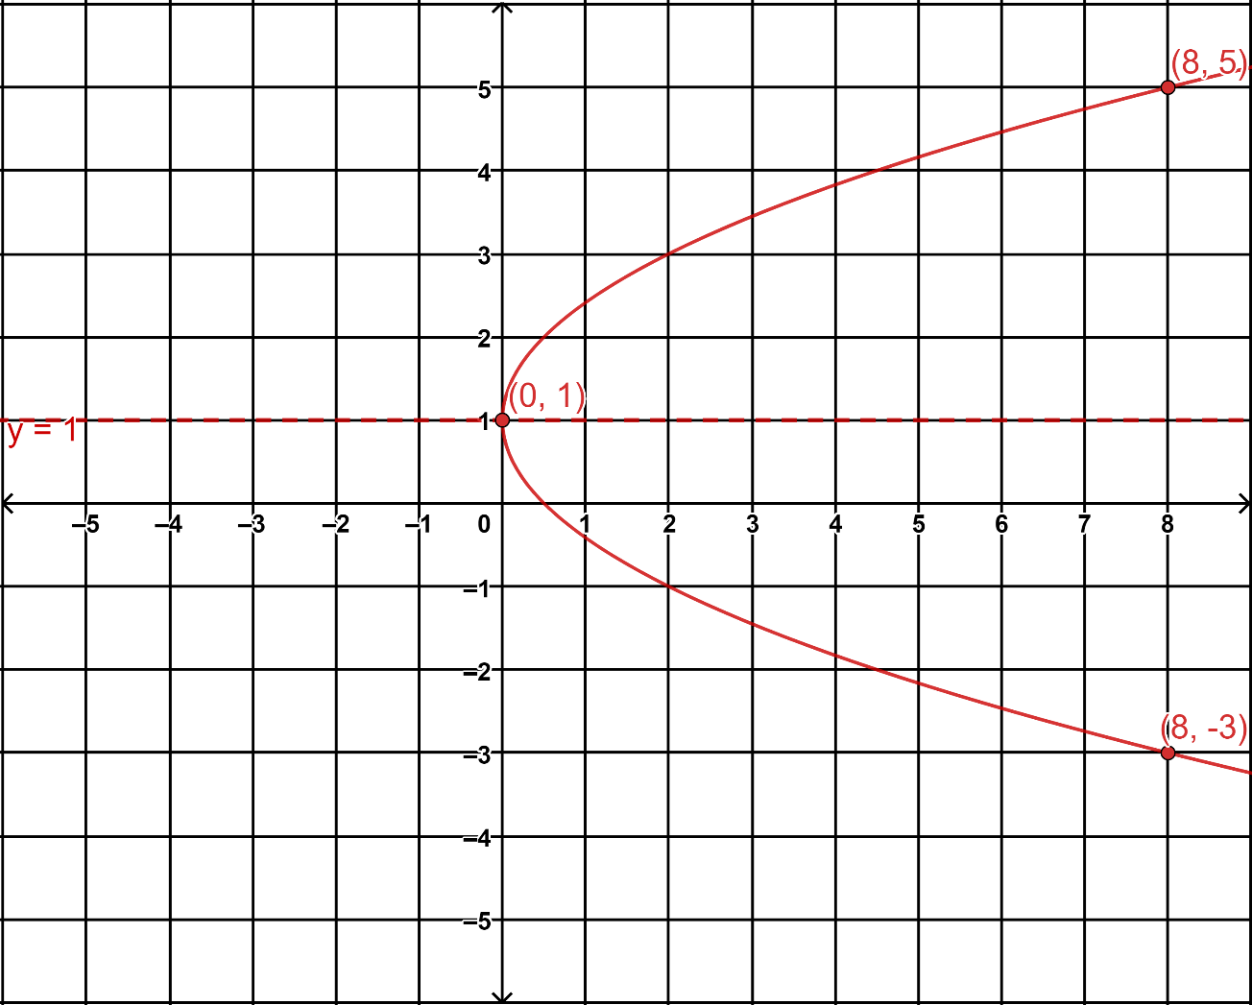

Specific behaviours
labels vertex (0,1)
draws and labels axis of symmetry y=1
parabolic shape with smooth curve

Question 4 {1.1.21, 1.1.28} (7 marks)
Consider the given graph below.

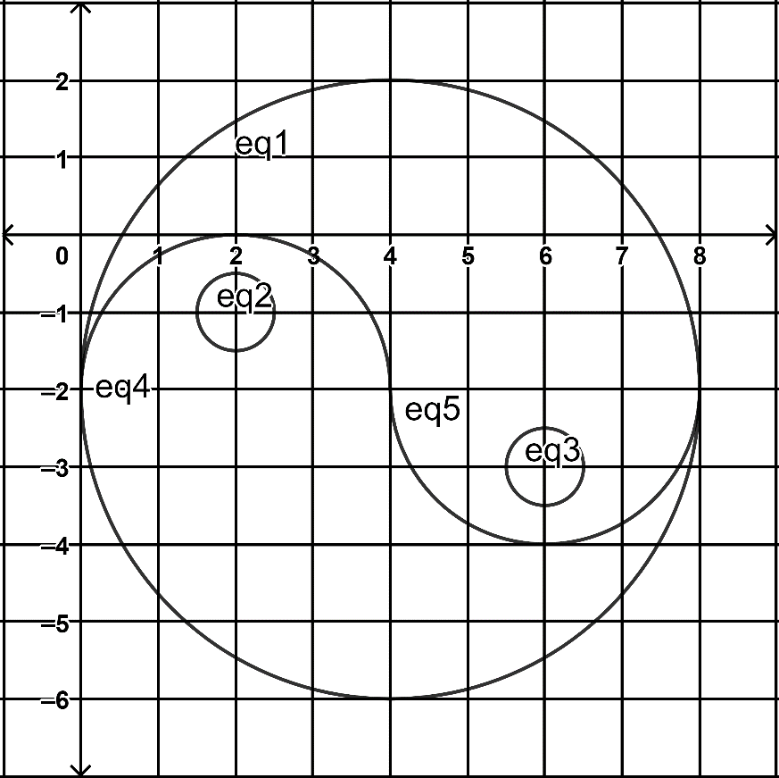
- Determine the equations of all the curves forming the shapes in the graph. (5 marks)
Solution
Eq1: ${(x-4)}^{2}+{(y+2)}^{2}=16$
Eq2: ${(x-2)}^{2}+{(y+1)}^{2}=\frac{1}{4}$
Eq3: ${(x-6)}^{2}+{(y+3)}^{2}=\frac{1}{4}$
Eq4: $y=\sqrt{{4-(x-2)}^{2}}-2$
Eq5: $y=-\sqrt{{4-(x-6)}^{2}}-2$
Specific behaviours
correct centre and radius for eq1
correct centre and radius for eq2
correct centre and radius for eq3
correct eq4 (accept ${(x-2)}^{2}+{(y+2)}^{2}=4$)
correct eq5 (accept ${(x-6)}^{2}+{(y+2)}^{2}=4$)

- List all the functions in the graph. Justify your answers. (2 marks)
Solution
eq4 & eq5. Use the vertical-line test: a vertical line can be drawn that intersects with the graphs of the above equations no more than once, and thus shows two functions.
Specific behaviours
lists the two functions
states vertical-line test

Question 5 {1.1.16, 1.1.17} (5 marks)
- Given that ${-6x}^{3}-13x^{2}+14x-3=(x+3)({bx}^{2}+cx-1)$ for all values of $x$, for suitable values of $b$ and $c$. Find $b$ and $c$ by equating coefficients.
(2 marks)
Solution
$$\left(x+3\right)\left(bx^{2}+cx-1\right)$$
$$=bx^{3}+cx^{2}-x+3bx^{2}+3cx-3$$
$$=bx^{3}+(3b+c)x^{2}+(3c-1)x-3$$
$$∴b=-6$$
$$c=5$$
Specific behaviours
correct value for b
correct value for c

- Consider the graph of polynomial $P(x)$ below. Determine the equation in the form $P\left(x\right)=a_{n}x^{n}+a_{n-1}x^{n-1}+ ∙ ∙ ∙ +{ a}_{1}x+a_{0}$. (3 marks)

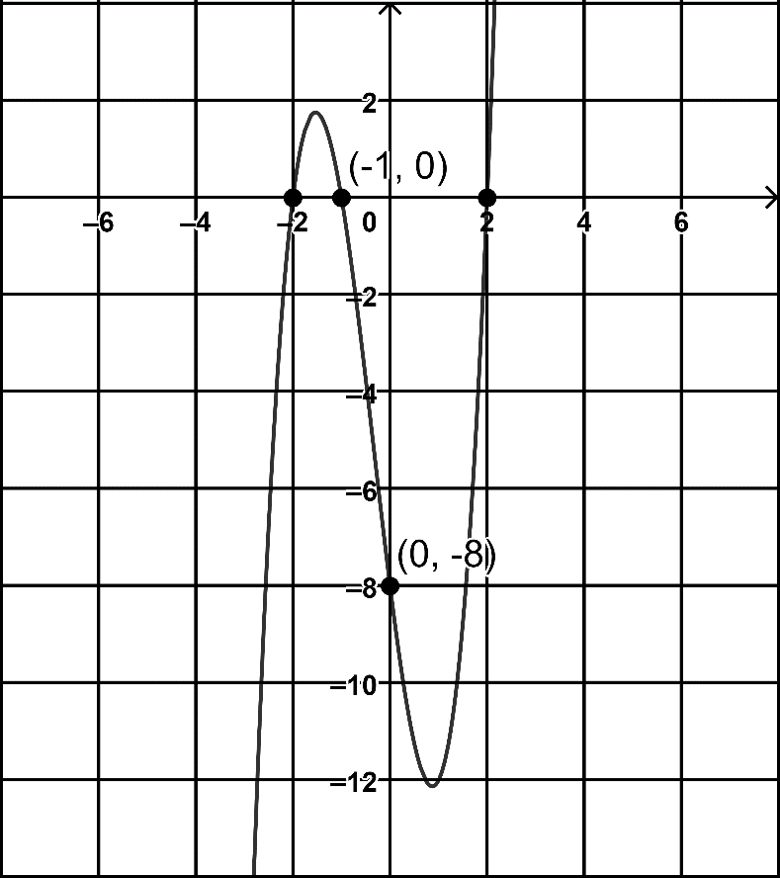

Solution
$$P(x)=a_{n}(x-2)(x+1)(x+2)$$
$$P\left(0\right)=a_{n}\left(-2\right)\left(+1\right)\left(+2\right)=-8⟹a_{n}=2$$
$$P(x)=2(x-2)(x+1)(x+2)$$
$$P(x)=2x^{3}+2x^{2}-8x-8$$
Specific behaviours
determines coefficient $a_{n}$
writes $P(x)$ in factorised form
writes $P(x)$ in general form as required
Question 6 {1.1.24, 1.1.25} (6 marks)
- State the natural/implied domain and range for each of the relations/functions below.
(3 marks)
Relation/Function | Natural Domain | Natural Range
$$y=\sqrt{x-3}+5$$ | 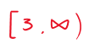 | 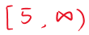
$$y=\frac{4}{2x+3}-5$$ | 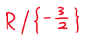 | 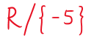
$${(x+1)}^{2}+{(y-2)}^{2}=9$$ | 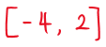 | 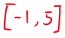

Specific behaviours
correct natural domain and natural range for $y=\sqrt{x-3}+5$
correct natural domain and natural range for $y=\frac{4}{2x+3}-5$
correct natural domain and natural range for ${(x+1)}^{2}+{(y-2)}^{2}=9$

- Sketch the graph of the function, $f:\left[-6, 2\right]→R, f\left(x\right)=\frac{1}{2}x^{2}+2x+3$, and state its range. (3 marks)
Solution
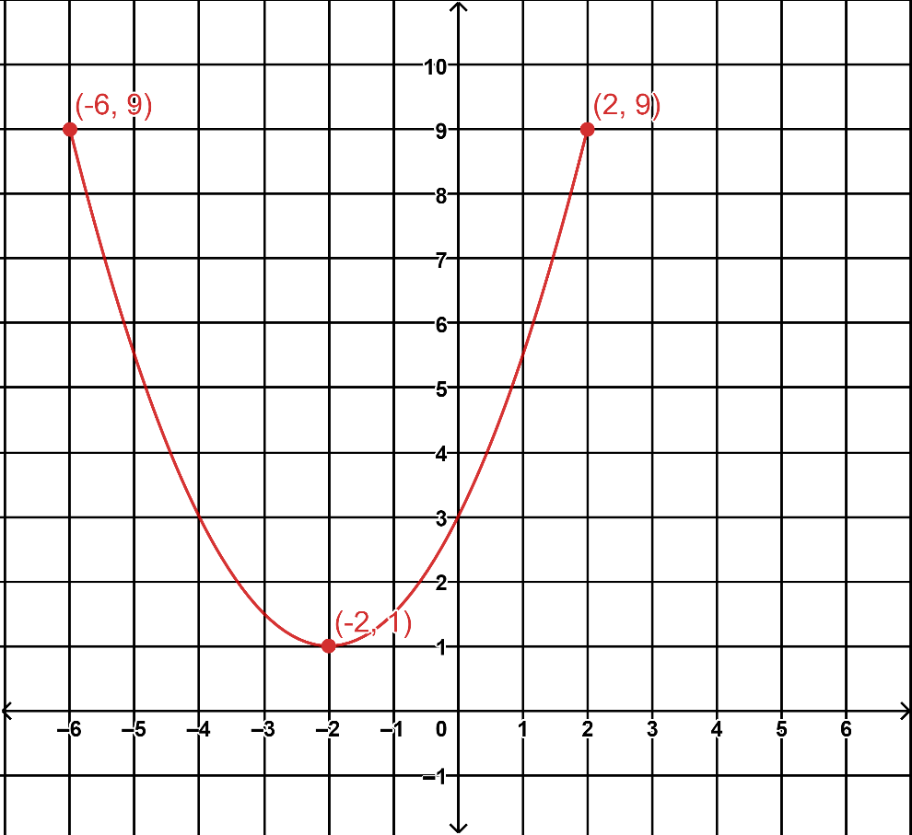
Range is $[1, 9]$
1/Specific behaviours
shape
plot or label points$(-6, 9)$ or $(2, 9)$
states the range

Question 7 {1.4.14} (5 marks)
A and B are independent events. $P\left(A∪B\right)=0.64$ and $P\left(A | B\right)=0.4$. Determine $P\left(B\right).$

Solution
Let $P(B)=x$
Since A and B are independent event
$$P(A)=P\left(A | B\right)=0.4$$
$P(A∩B)=P(A)×P(B)=0.4x$
Also, $P\left(A∩B\right)=P\left(A\right)+P\left(B\right)-P\left(A∪B\right)$
$$P =0.4+x-0.64$$
$$x-0.24=0.4x$$
$$x=0.4$$
Hence, $P(B)=0.4$
Specific behaviours
states $P(A)$ is 0.4
uses $P(A∩B)=P(A)×P(B)$
uses $P\left(A∪B\right)=P\left(A\right)+P\left(B\right)-P\left(A∩B\right)$
forms an equation with $P(B)$
correct number for $P(B)$

Question 8 {1.1.19} (5 marks)
Let $P\left(x\right)=x^{3}+kx^{2}-\left(k+3\right)x-2k-2$

- Show that $P\left(x\right)$ is divisible by $x+1$. (1 mark)

Solution
$$P(x)=(-1)+k+k+3-2k-2$$
$$P(x)=0- )+k+k+3-2k-2$$
By the Factor Theorem, $P(x)$ is divisible by $x+1$.
Specific behaviours
uses the Factor Theorem

- Factorise $P\left(x\right)$ fully. (4 marks)

Solution
$x^{2}+(k-1)x-2k-2$
$$x+1⟌\overline{ x^{3}+kx^{2}-(k+3)x-2k-2}$$
$-) x^{3}+x$
$(k-1)x^{2}-(k+3)x$
$-) {(k-1)x}^{2}+(k-1)x$
$\left(-2k-2\right)x-2k-2$
$-) \left(-2k-2\right)x-2k-2$
$\overline{ 0 0 }$
$$P\left(x\right)=(x+1)\left[x^{2}+(k-1)x-2(k+1)\right]$$
$$=\left(x+1\right)\left(x-2\right)\left(x+k+1\right)$$

Specific behaviours
beginning a division or comparing coefficients
finding $a=1$
finding the correct quotient in full
factorising the quotient

END OF SECTION ONE
Additional working space
Question number:

Additional working space
Question number:

